Comprehensive AMC –Corrective Maintenance Flow

L1 log the complaint

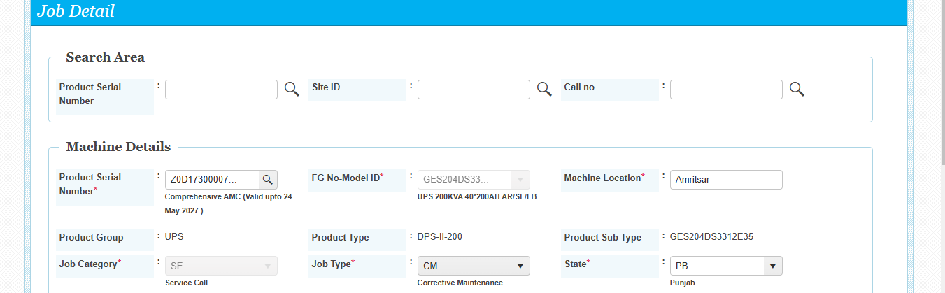

L1 Assign the Job to L2

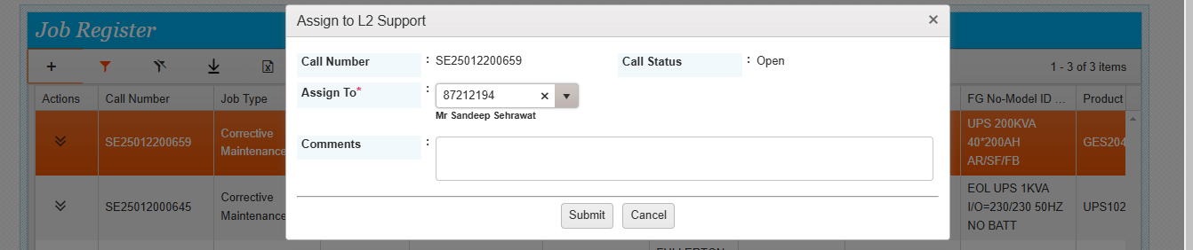

L2 add recommend some parts

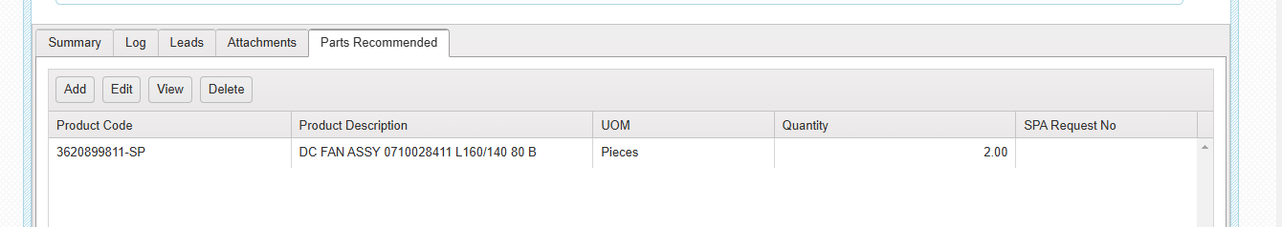

Comprehensive AMC –Corrective Maintenance Flow

L2 assign the job for onsite support

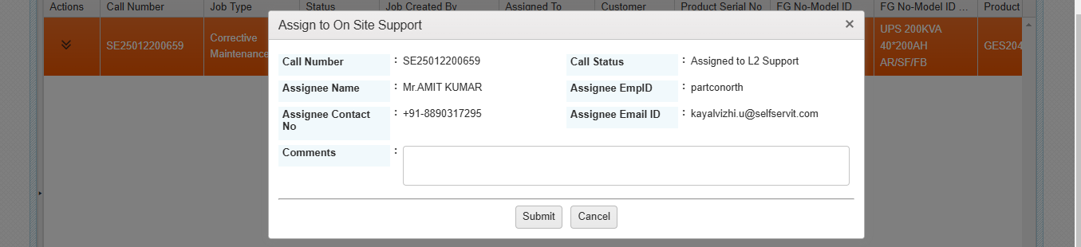

Assign to onsite support done successfully

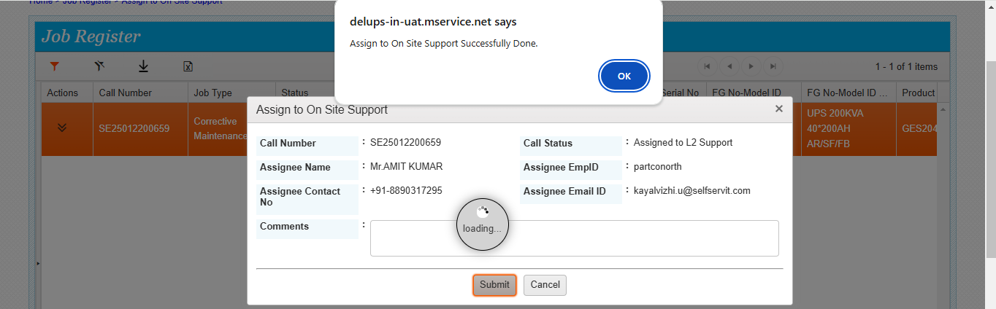Assigned to Parts coordinator as the machine is under Comprehensive AMC.

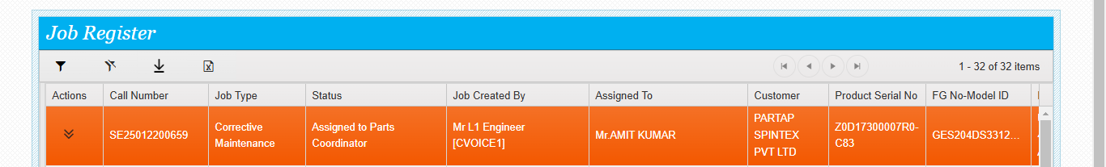Parts coordinator assigned the warehouse for the required parts.

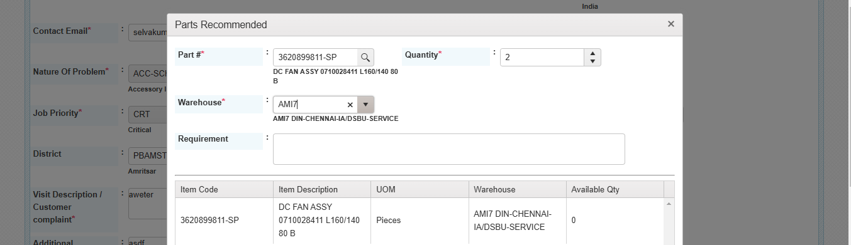

Comprehensive AMC –Corrective Maintenance Flow

Parts coordinator generated the spare request after allotting the warehouse.

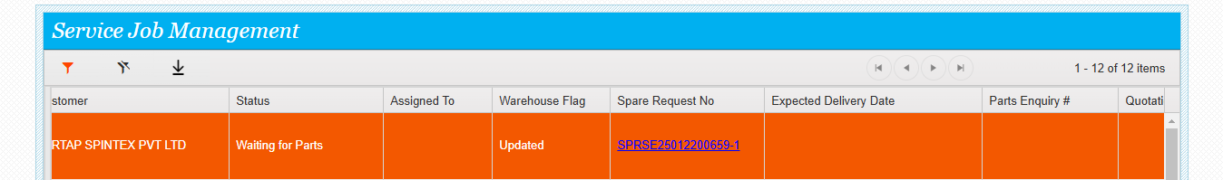

Spare request assigned to Parts coordinator

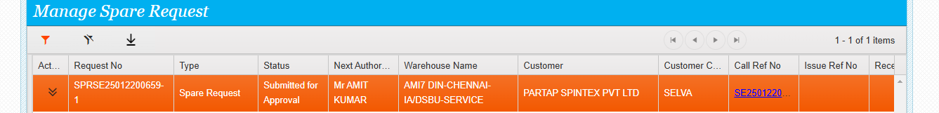

Spare request approved by the parts coordinator

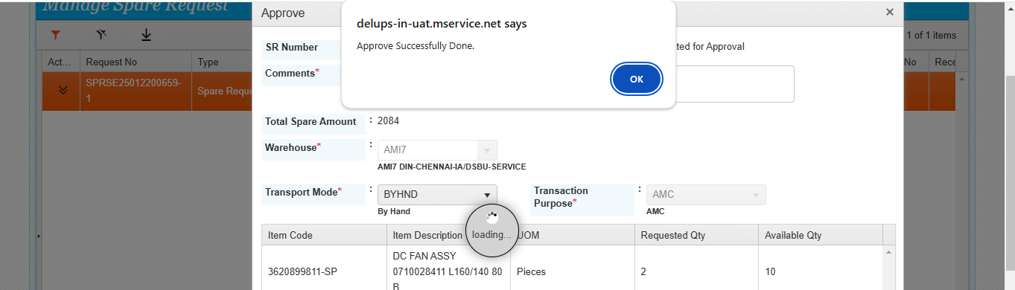Spare request approved by the national manager

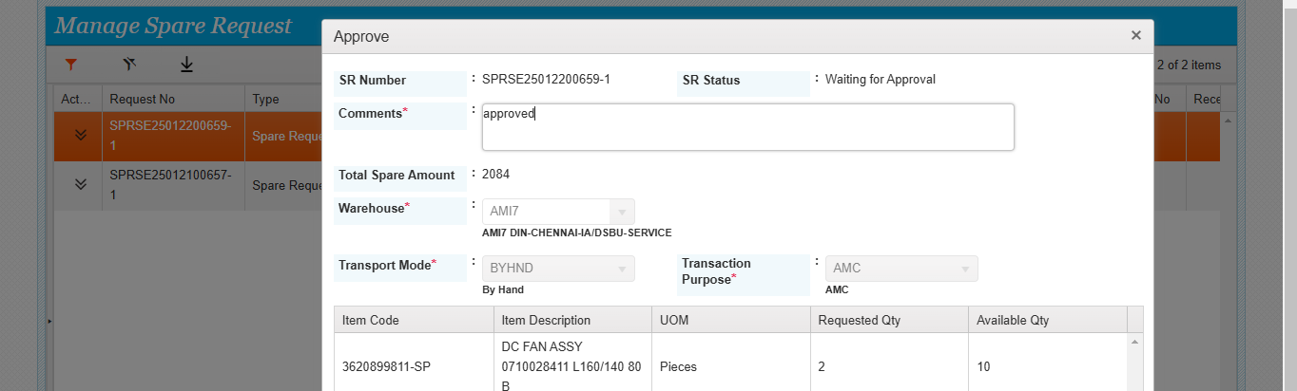

Comprehensive AMC –Corrective Maintenance Flow

Issue generated and assigned to the parts coordinator for SO DO

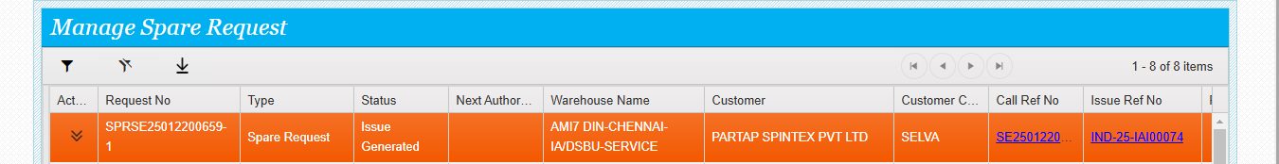

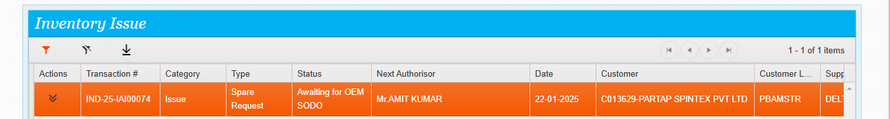

Parts coordinator does the SO DO update

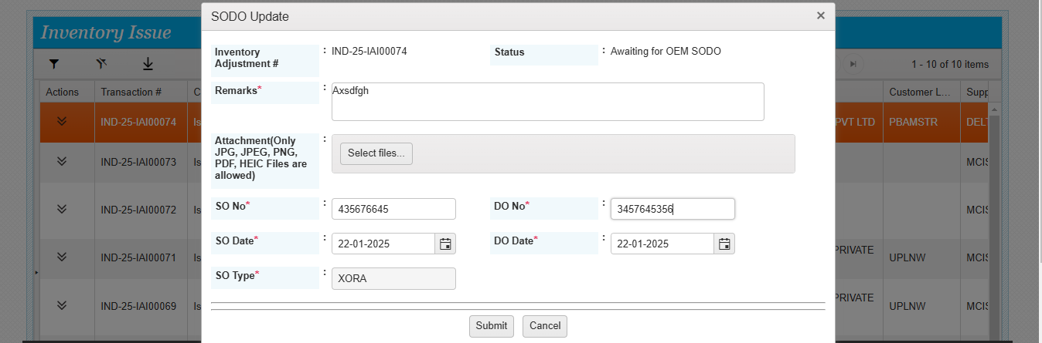SO DO done successfully.

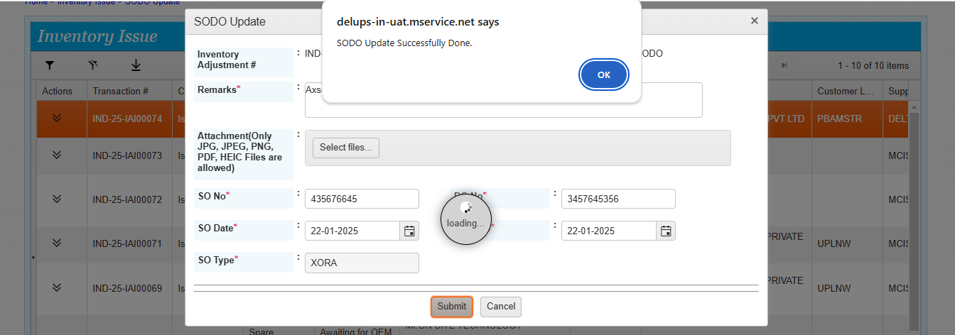

Comprehensive AMC –Corrective Maintenance Flow

Issue assigned to respective Mother warehouse for logistics update

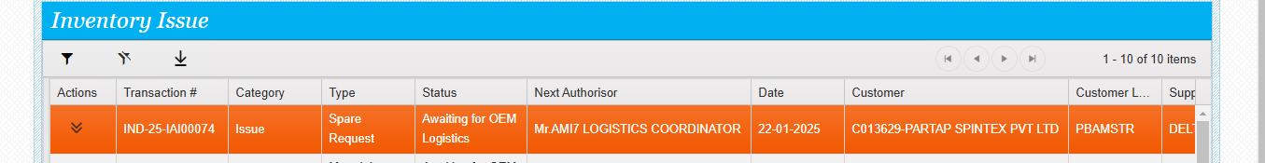Logistics done successfully

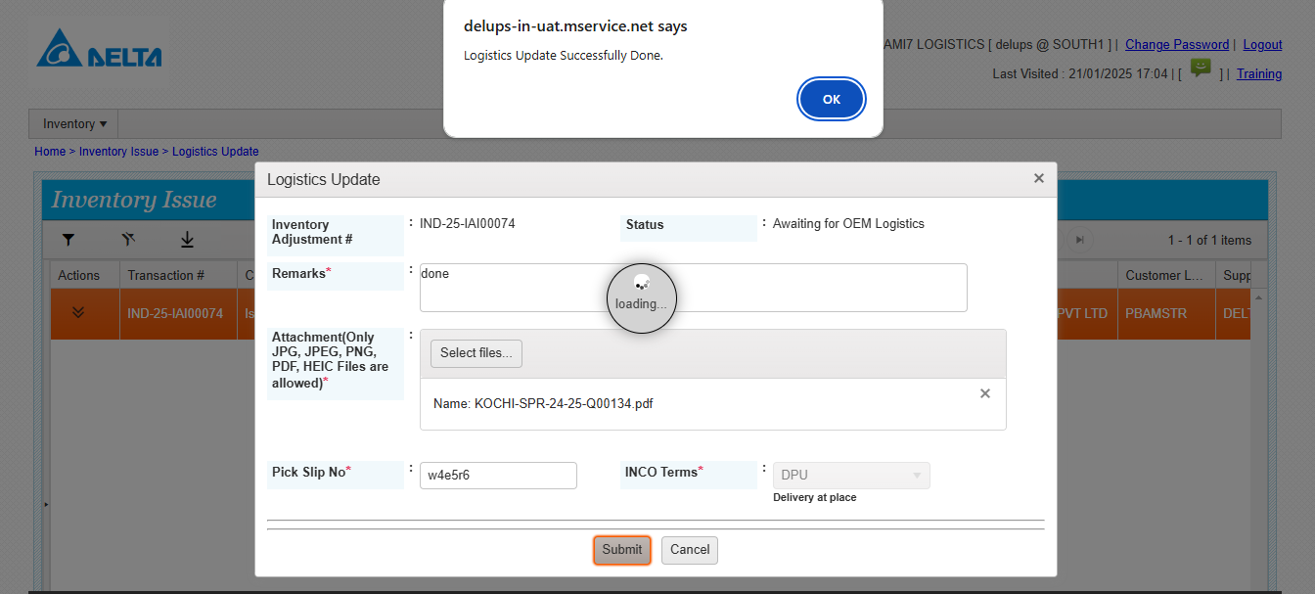Pick pack done successfully

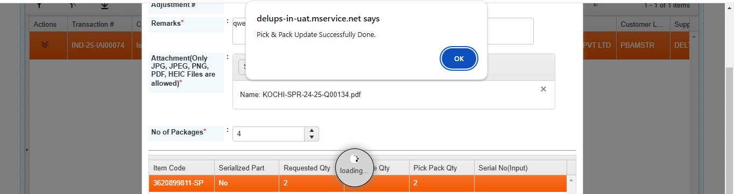

Comprehensive AMC –Corrective Maintenance Flow

Despatch done successfully

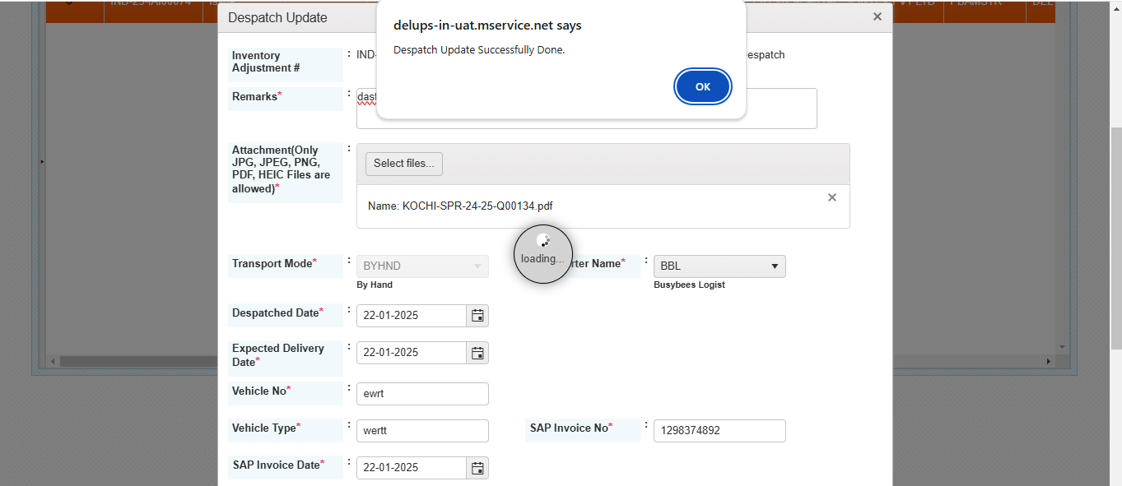Call status changed to Assigned to service coordinator. As this machine is mapped with delta, The call is now assigned to Delta regional coordinator.

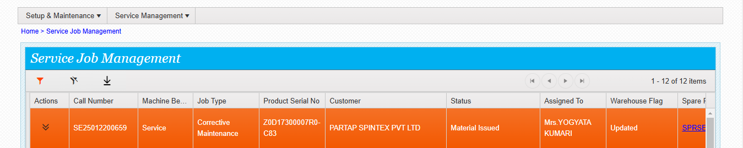Now the service coordinator can see the assigned calls in his /her login and assign the call to engineer. Service Job assigned to engineer successfully. The engineer will do the process and complete the service call.

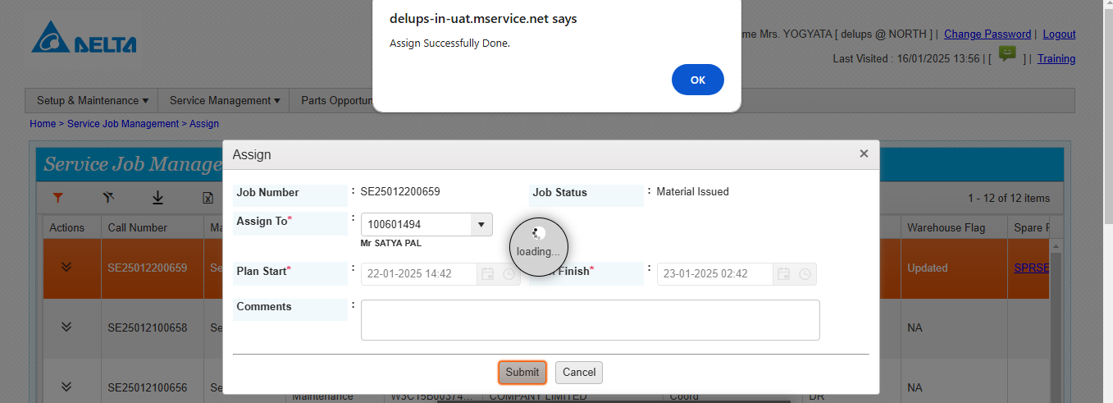

NON-COMPREHENSIVE AMC FLOW

L1 Support log the complaint for Non-Comprehensive machine corrective maintenance

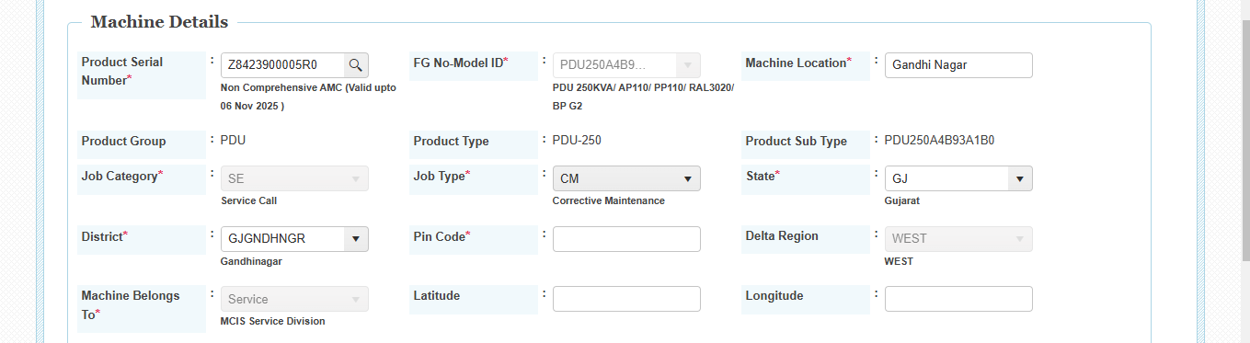Call generated successfully.

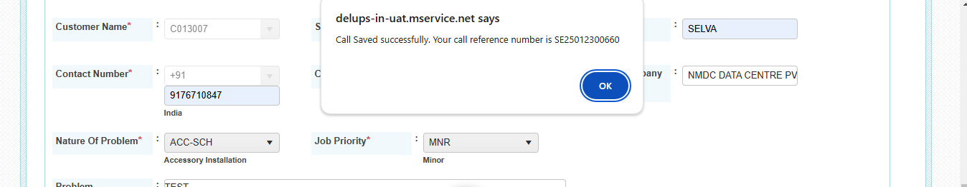L1 can assign the job to l2 or onsite support

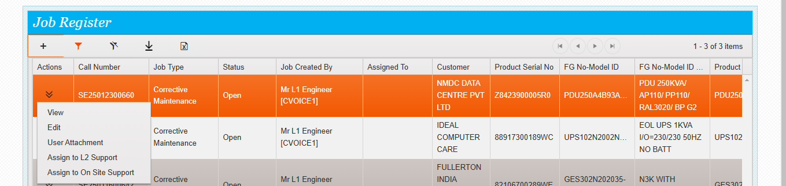

NON-COMPREHENSIVE AMC FLOW

L1 clicks onsite support action then the below screen will appear

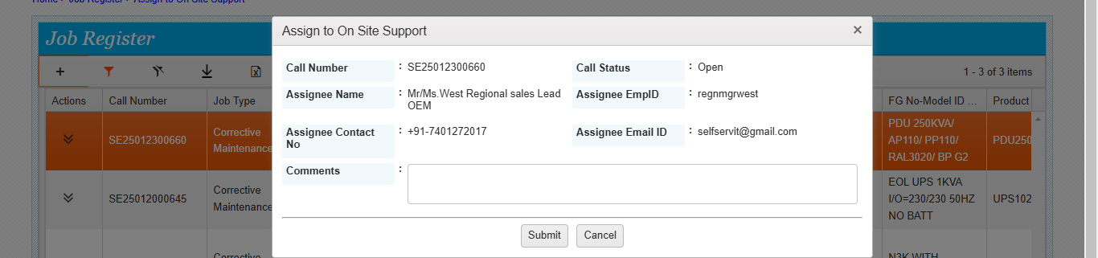

As this machine is under NON comprehensive machine the service call will be assigned to Delta sales Lead, As per the mapping the system may pick the respective regional sales lead

Now the job is assigned to delta sales lead,

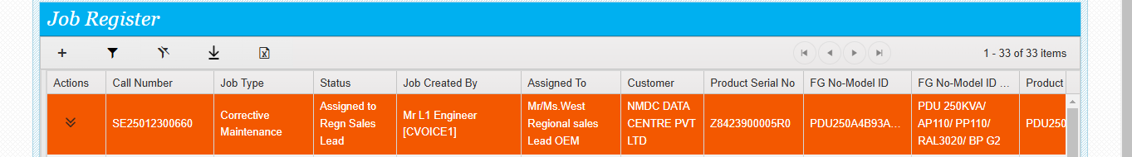Regional sales lead can assign the job to onsite directly or can do the quote generation

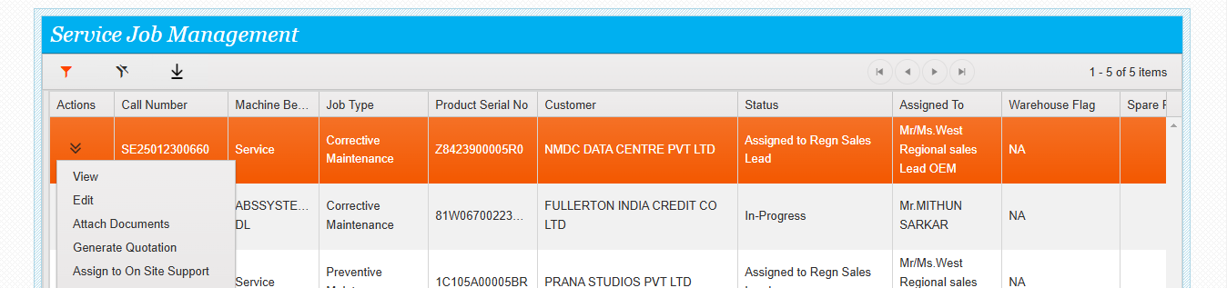If sales lead clicks assigned to onsite support the below screen will appear.it picks the respective regional coordinator.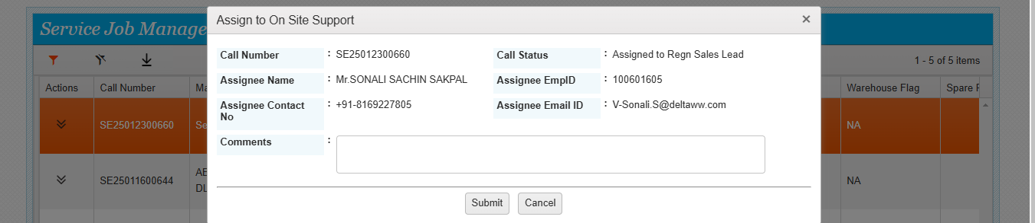

NON-COMPREHENSIVE AMC FLOW

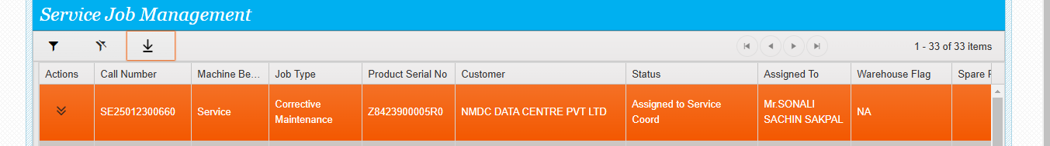Now coordinator can assign this job to service engineer

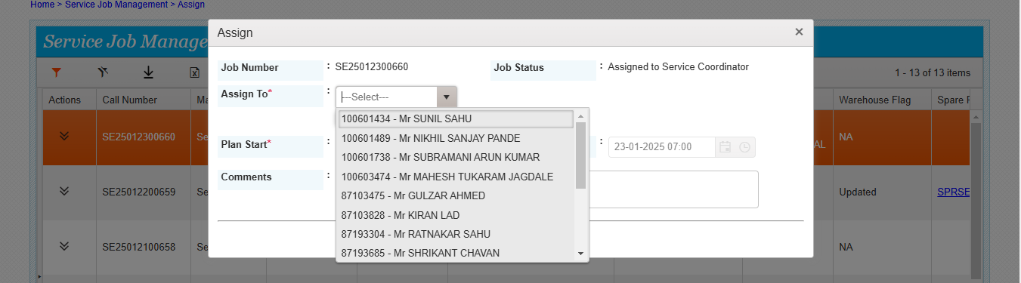Job assigned to service engineer

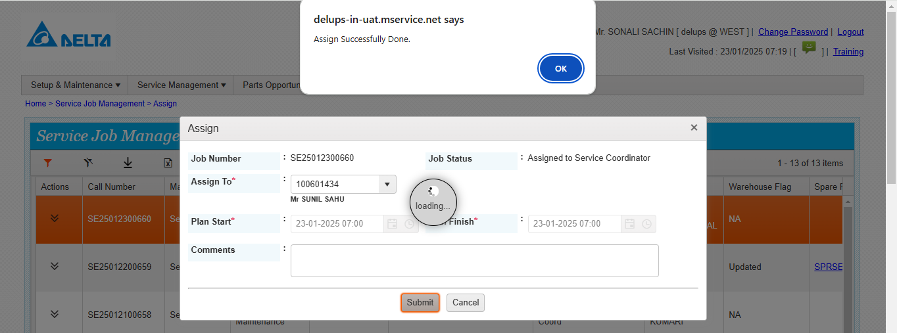Engineers will do the further process. Trip start, finish, work start, work finish,

If any further spares are required, he may submit the DSR along with the parts list.

Then the system will generate the parts enquiry ticket, and it will be assigned to the respective coordinator for further process. At the same time the call will be kept on hold, Release hold can be done by the respective coordinators once release hold is done engineer can do the further process on that call.

Once the job is over engineers will submit the FSR and complete the service call.

END